**Overview**

Work individually to understand and establish the specifications for a PC dedicated to a specific task or application.

My PC application topic is *Photo Editing and Organization*

Answering student questions will help you to develop a deeper understanding of the main components of a personal computer. It will also help you to identify the features that are most important for your specific PC application topic and the features that are nice to have but are not as critical for your topic.

Preparing a brochure explaining your PC application topic and your selection of personal computer components and features will help you to summarize what you have learned from the student questions. The brochure will also help you to share your findings in a “tradeshow” to be held in class.

The date for the “tradeshow” is:

Student Questions

1. Think about your PC application topic. Do some research to find general answers to the following questions.

1. How important is computer speed for my topic ( High / Medium / Low)? Justify your answer using examples of how a computer is used to perform a task related to your application.
   1. This is a medium priority because photo editing does not need to have an extremely high computing speed since reaction time, quickness, and response times will not be a deciding factor. However, one would not like a computer that has a slow speed, lots of lag, or  a slow response time.
2. How important is data storage for my topic ( High / Medium / Low)? Justify your answer using examples of how a computer is used to perform a task related to your application.
   1. This is a high priority as one will need to store lots of files on the computer for the original and finished product of the photo, programs to edit the photos, and extensions to better manipulate the photo.
3. How important is graphics and sound for my topic ( High / Medium / Low)? Justify your answer using examples of how a computer is used to perform a task related to your application.
4. How important is internet connectivity for my topic ( High / Medium / Low)? Justify your answer using examples of how a computer is used to perform a task related to your application.

2. CPU Processor Chip

1. What speed of CPU Chip do you require? (High / Medium / Basic)
   1. This needs a medium CPU chip as it will be able to take everything one step at a time, through one or two programs. Also, long wait times will not affect the quality finished and edited photo.
2. Provide an example of a high speed CPU using the list of suppliers provided in the appendix. List the Model Number, Price, and Vendor Source. Also list its main features
   1. AMD Ryzen 9 3900X, is priced at $709.00, and can be found at canadacomputers.com. It has 12 cores and 24 threads. It has a base clock of 3.8GHz, a max boost clock of 4.6GHz, the total M2 cache is 6MB, and the total M3 cache is 64MB.
3. Provide an example of a medium speed CPU using the list of suppliers provided in the appendix. List the Model Number, Price, and Vendor Source. Also list its main features
   1. Intel Core i9-9900K, the price is $699.99, and one can buy this product at canadacomputers.com. This chip has 8 cores, and 16 threads. The base frequency is 3.60 GHz, it has a total cache of 16 MB, and its max turbo frequency is 5 GHz.
4. Provide an example of a basic speed CPU using the list of suppliers provided in the appendix. List the Model Number, Price, and Vendor Source. Also list its main features
   1. AMD Ryzen 7 2700 3.2 GHz 8-Core Processor, is $174.99, and one can buy this product at canadacomputers.com. It has eight cores and sixteen threads, the operating frequency is 3.2 GHz, and the max turbo frequency is 4.1 GHz. It also has a total cache of 20MB.
5. What would be the least expensive CPU Chip that meets your requirements? List the Model Number, Price, and Vendor Source.
   1. Intel Core i9-9900K, the price is $699.99, and one can buy this product at canadacomputers.com.

3. RAM Memory

1. What size of RAM Memory do you require? (Large / Medium / Basic)

This would need a medium or small RAM  size since

1. Provide an example of a large size RAM using the list of suppliers provided in the appendix. List the Model Number, Price, and Vendor Source. Also list its main features
   1. G.SKILL TridentZ RGB Series, costs $201.99, modle: F4-3200C16D-32GTZR, and this is found at https://www.newegg.ca. This product comes with two components, each carrying 16 GB of memory, clocking it in at 32 GB, and the speed is DDR4 3200, the CAS Latency is 16 and its needs 1.35V.
2. Provide an example of a medium size RAM using the list of suppliers provided in the appendix. List the Model Number, Price, and Vendor Source. Also list its main features
   1. G.SKILLG.SKILL TridentZ RGB Series 16GB (2 x 8GB) 288-Pin DDR4 SDRAM DDR4 3200 (PC4 25600) Desktop Memory Model F4-3200C16D-16GTZR, model  N82E16820232476, it costs $94.99, and one can buy this at https://www.newegg.ca. It has a total capacity of 16 GB of storage with 2 cards each able to hold 8 GB, and the speed isDDR4 3200. It has a CAS Latency of 16, and uses 1.35V.
3. Provide an example of a basic size RAM using the list of suppliers provided in the appendix. List the Model Number, Price, and Vendor Source. Also list its main features
   * 1. CORSAIR Vengeance LPX, model: CMK8GX4M2C3000C16, priced at $64.99, and one can buy this at https://www.newegg.ca. It has two components each able to store 4 GB of data, meaning that it has a total capacity of 8 GB. Its speed is DDR4 3000, 16 CAS Latency, and needs 1.35 V.
4. What would be the least expensive RAM Memory that meets your requirements? List the Model Number, Price, and Vendor Source.
   1. CORSAIR Vengeance LPX, model: CMK8GX4M2C3000C16, priced at $64.99, and one can buy this at https://www.newegg.ca.

4. Graphics Card

What graphics speed and resolution do you require? (High / Medium /Basic - On Motherboard)

1. Provide an example of a high-end Graphics Card using the list of suppliers provided in the appendix. List the Model Number, Price, and Vendor Source. Also list its main features
   1. A high- end Graphics card includes the AMD Radeon RX 5700, made by AMD Radeon. It’s sold for $574.99 on canadascomputer.ca. The main features of the graphic card are that its powered by 7nm Radeon RDNA architecture, WINDFORCE 3X with Alternate Spinning Fans & 5 Direct Touch Copper Heatpipes, 3 x Display Port 1.4, 1 x HDMI 2.0b.
2. Provide an example of a medium-end Graphics Card using the list of suppliers provided in the appendix. List the Model Number, Price, and Vendor Source. Also list its main features
   1. A medium-end Graphics Card is EVGA GeForce RTX 2070 SUPER, made by EVGA. It’s sold for $690.00 on Newegg. The main features of the product are, 8GB 256-Bit GDDR6, Boost Clock 1770 MHz, 1 x HDMI 2.0b 3 x -DisplayPort 1.4, 2560 CUDA Cores and PCI Express 3.0.
3. What would be the least expensive Graphics Card that meets your requirements (or do you just need basic graphics provided by the motherboard)? List the Model Number, Price, and Vendor Source.
   1. A basic and least expensive Graphics Card is Sapphire PULSE Radeon RX 580, made by Sapphire tech. It’s sold for $185.00 on Newegg.

5. Sound Card

Do you require special sound support? (High / Medium /Basic - On Motherboard)

1. Provide an example of a high-end Sound Card using the list of suppliers provided in the appendix. List the Model Number, Price, and Vendor Source. Also list its main features
   1. A high-end Sound Card is Creative’s product the Creative Sound Blaster Z. It’s sold for $114.99 on Newegg. PCI Express x1, 5.1 Channels, TOSLink Optical Input and Output, Sound Core 3D Processor and Beamforming Microphone.
2. Provide an example of a medium-end Sound Card using the list of suppliers provided in the appendix. List the Model Number, Price, and Vendor Source. Also list its main features
   1. A medium- end sound card is ASUS STRIX SOAR Sound Card, created by Anus. it’s sold for $114.99 on Newegg. Some of the main features include 8 Channels, 44.1K / 48K / 88.2K / 96K / 176.4K / 192KHz, PCI Express Interface
3. What would be the least expensive Sound Card that meets your requirements (or do you just need basic sound provided by the motherboard)? List the Model Number, Price, and Vendor Source.
   1. A basic sound card iStarTech 7.1 Channel Sound Card PEXSOUND7CH, created by Star tech. it’s sold for $69.99 on Newegg. Some of the main features are that it Supports digital optical or analog audio devices through SPDIF or 3.5mm jacks, Three internal auxiliary inputs (2x CD/DVD-IN and 1x Intel HD front panel audio) and Supports ASIO and WASAPI

6. Motherboard

1. Do you require any special motherboard features (based on your answers to the above questions)?
   1. No
2. Provide an example of a high-end Motherboard using the list of suppliers provided in the appendix. List the Model Number, Price, and Vendor Source. Also list its main features
   1. MSI PRESTIGE X570 CREATION, the item number is N82E16813144258, it costs $639.99, and is found at newegg.com. It has an AMD X570 chipset, it has 4 memory slots, each with 288pin, it has 6 SATA each running at 6Gb/s. It has 7 HD audio ports, holds 128GB of data.
3. Provide an example of a basic Motherboard using the list of suppliers provided in the appendix. List the Model Number, Price, and Vendor Source. Also list its main features
   1. GIGABYTE Z390 UD LGA 1151 (300 Series), the model number is N82E16813145095, it costs $167.99, and can be found at newegg.com. The socket type is LGA 1151, it has 4 288pin memory slots, and a Realtek GbE LAN chipset.
4. What would be the least expensive Motherboard that meets your requirements? List the Model Number, Price, and Vendor Source.
   1. ASRock B450M PRO4 AM4 AMD Promontory, its item number is N82E16813157843, it costs $89.99, and is found at canadacomuters.com. It has 4 288pin memory slots, it supports 64GB memory, has a Realtek ALC892 audio chipset  and and it has SATA3 6.0Gb/s Connectors.

7. HDD (Hard Disk Drive or Solid State Drive)

1. Do you require any special Hard Disk Drive features (based on your answers to the above questions)?
2. Provide an example of a high-end HDD using the list of suppliers provided in the appendix. List the Model Number, Price, and Vendor Source. Also list its main features
   1. Seagate BarraCuda ST8000DM004, the model number is N82E16822183793, it costs $149.99 and is found at newegg.com. It stores 8 TB of data, has a SATA 6.0Gb/s interface. It has an RPM of 5400, and a 256MB cache.
3. Provide an example of a basic HDD using the list of suppliers provided in the appendix. List the Model Number, Price, and Vendor Source. Also list its main features
   1. Seagate BarraCuda ST1000DM010, the model number is N82E16822179010, it costs $43.99 and is found at newegg.com. It stores 1 TB of data, has a SATA 6.0Gb/s interface. It has an RPM of 7200, and a 64MB cache.
4. What would be the least expensive Hard Disk Drive that meets your requirements? List the Model Number, Price, and Vendor Source.

8. Removable Media (DVD / USB / Flash)

1. Do you require any special Removable Media features? Explain what extra features are required for your PC application topic.
2. If so, List the Model Number, Price, and Vendor Source for any of these extra features.

|  |  |  |
| --- | --- | --- |
| External CD Drive USB 3.0 Portable Slim External DVD Drive | $38.46 | This product allows you to insert a disk and play it on your PC. |
| SAMSUNG 64GB BAR PLUS (Metal) USB 3.1 Flash Drive, SpeedUp to 200MB/s (MUF-64BE4/AM) | $25.99 | This can be used for extra storage. |

9. Network Interface (Ethernet /Fiber / Wi-Fi / Bluetooth)

1. Do you require any special Network Interface features? Explain what extra features are required for your PC application topic.
2. If so, List the Model Number, Price, and Vendor Source for any of these extra features.

|  |  |  |
| --- | --- | --- |
| Coboc CY-CAT6-05-BK 5ft. 24AWG Snagless Cat 6 Black Color 550MHz UTP Ethernet Stranded Copper Patch cord /Molded Network lan Cable | $5.99 | Etherent provides a strong connection with wiring. |
| Rosewill RNX-N150UBEv3, Wireless N150 Wi-Fi Adapter, IEEE 802.11b/g/n, Up to 150 Mbps Wireless Data Rates, USB 2.0 Interface, 1 x 5 DBi Detachable High Gain Antennas, Win 10 Support | $13.99 | USB that strengthens your wifi. |
| IOGEAR GBU521 USB Bluetooth 4.0 Micro Adapter | $30.99 | Stronger bluetooth connection |

10. Monitor, Mouse, Keyboard

Do you require any special Monitor, Mouse, Keyboard, etc. add-ons? Explain what extra features are required for your PC application topic.

1. If so, List the Model Number, Price, and Vendor Source for any of these extra features.

|  |  |  |
| --- | --- | --- |
| Samsung S24E450DL 23.6" Full HD Business Monitor | $206.42 | Output device that displays pictorial form. |
| Microsoft Wireless Mobile Mouse 4000 for Business Black 4 Buttons Tilt Wheel USB 2.4 GHz RF BlueTrack 1000 dpi | $29.98 | Allows you to use your PC without the PC |

11. Portability / Mobility

Will you be using your PC in one place, do you need some portability, or do you need a high degree of mobility? Explain the need for portability  your PC application topic.

1. Do you require a Desktop / Laptop / Notebook or other PC format?
2. How will this affect the cost of your dream machine.

12. Rank each personal computer component in order of priority (1-lowest, 10-highest) based on your research above. Each component must have its own priority number… no duplications.

CPU Processor Chip 1  2 3  4 5 6  7 8 9  10

RAM Memory 1  2 3  4 5 6  7  8 9  10

Graphics Card 1  2 3  4  5 6  7 8 9  10

Sound Card 1  2 3  4 5 6  7 8 9 10

Motherboard 1  2 3  4 5 6  7 8 9  10

HDD (Hard Disk Drive or Solid State Drive) 1  2 3  4 5 6  7 8  9 10

Removable Media (DVD / USB / Flash) 1  2 3  4  5 6  7 8 9  10

Network Interface (Ethernet /Fiber / Wi-Fi / Bluetooth) 1  2 3  4 5  6 7 8  9 10

Monitor, Mouse, Keyboard 1  2 3  4 5 6  7 8 9 10

Portability / Mobility 1  2 3  4 5 6  7 8 9 10

**Brochure**

Work individually to create a 4 page brochure according to the following guideline.

Page 1 – Your Application Topic

Describe your topic and the top PC components for your topic.

Include the following on this page:

* Describe your application topic and how a PC is used
  + Photo editing refers to touching up, cropping, and manipulating photos through special programs including adobe photoshop, ACDSee, Corel PaintShop Pro, and Zoner Photo Studio. One may use this to create special effects such as emphasis, inaccurate proportion, changing the background, etc. One can also use this computer for simpler tasks such as cleaning one’s skin or changing the colour of one’s clothing in a photo. Organization refers to creating a slideshow, or logically arranging (of) photos with certain programs including windows movie maker, iMovie, and Adobe Bridge. One may use this computer to create slideshow that could serve as a present, pastime, or a preservation of memories.
* In general terms, describe what the best PC for this application would look like (e.g. speed vs portability)
  + The best PC would need a better monitor than storage, better storage than speed, better speed than internet conductivity, and better internet conductivity than portability.
* Describe in more detail the top three most important PC components and explain why they are important for your application
  + For this PC, one would want to have a larger memory or storage. This is because one would need to find space to accommodate the original and edited photos for a topic. Also, slideshows will take up more space as they have many photos mixed into one video and one needs all of the necessary software to create the finished product and luxury add ons.
  + Another important feature would be the monitor. More specifically, one would need a monitor that has a lot of display colours so that they could see all the different parts to the photo and edit and organize them in a more efficient manner. Also, one would need a monitor with USB and SD card ports so that one can upload and download images quickly and easily.
  + The third most important feature would be the CPU Chip. This is important as it will shorten the amount of time the computer takes to complete a task. This is useful as it will make it easier for the user to edit photos as there will be a faster response time if the computer has a better CPU Chip.

Page 2 – Would-Be-Nice Features

Describe your decisions about what PC components are less important but would be nice to upgrade if you had the money.

Include the following on this page:

* Describe the would-be-nice components (just below your top 3 priorities) and what your options for upgrading them would be.
  + One component that would be nice to upgrade is the motherboard. This is because it keeps all of the components together and running smoothly. As a result, this, or any, computer without a motherboard will not work as there will be no way for the components to work together in order to complete any tasks necessary.
* Describe the components / features at the bottom of your priority list and why you would not spend extra money on them.
  + One thing that would be nice to spend more on or have is a graphics card. This will enhance the quality of the image which will ensure that the user can edit the photo to the best of their ability. However, this is not a top priority as the finished product will rely on the skill of the user more than the graphics of the image.
* Provide some details about different vendors / suppliers and the options they offer.
  + One can buy computers and computer parts from newegg.com. This vendor has a large selection of parts and computers that one can choose from. It also gives specs on certain parts and allows you to compare different parts.

Page 3 – Your Budget Machine (Model number, price, usage)

Your budget is $800. Select a pre-packaged PC or customize / build a PC from parts to fit under this budget.

Include the following on this page:

* Your PC specs, model, cost, vendor, etc.

|  |  |  |
| --- | --- | --- |
| * 16 GB of Ram | • 1 TB of internal storage | • Monitor supports 1 billion colors |
| • 18 Cores (CPU) | • 64MB cache (HDD) | • 3840 x 2160 4K Resolution |
| • 16 Threads (CPU) | • No graphics card | • 1 ms response time (Monitor) |
| • 3.2 GHz (CPU | • No audio card | • AMD Promontory B450 (Motherboard) |
| • 28" Screen Size | • CAS Latency: 16 (RAM) | • SATA3 6.0Gb/s Connectors (Motherboard) |

* Priority components that you were able to include for this price.
  + *Mouse-*USB 2.0 2.4GHz RF Wireless Mouse, 9SIACUE5Y00341, ($5.59)
  + *Keyboard*, 9SIAH41A0C9439, ($10.10)
  + *Monitor*, 0JC-0007-00G35, ($349.99)
  + *CPU*, N82E16819113498, ($174.99)
  + *Motherboard*, N82E16813157843,($74.99)
  + *RAM,* N82E16820232476, ($94.99)
  + *HDD*, N82E16822179010, ($43.99)
    - Total- $754.31
* Priority components that you had to leave out because of budget limitations. (Talk about sound/graphics card)
  + I did not leave out any priority components as I was able to create a pc using basic components. This was achievable because  photo editing and organization requires very little computing power as it does not need a sound or graphics card. However, one would like to have a monitor that supports a large variety of colours so that one would be able to better edit the photo as they can clearly see all the different parts of the image. However, the budget forced cuts in other places such as the motherboard, HDD, RAM and more.

Page 4 – Your Dream Machine (Model number, price, usage)

Your budget is $2000. Select a pre-packaged PC or customize / build a PC from parts to fit under this budget.

Include the following on this page:

* Your PC specs, model, cost, vendor, etc.

|  |  |  |
| --- | --- | --- |
| * 32 GB of Ram | • 8 TB of internal storage | • Monitor supports 10 billion colors |
| • 12 Cores (CPU) | • 64MB cache (HDD) | • 3840 x 2160 4K Resolution |
| • 24 Threads (CPU) | • Graphics card: Yes | • 4 ms response time (Monitor) |
| • 3.8 GHz (CPU) | • Audio card: No | • AMD X570 Chipset (Motherboard) |
| • 27" Screen Size | • CAS Latency: 16 (RAM) | • 6 x SATA 6Gb/s Connectors (Motherboard) |

* Priority components that you were able to include for this price.
  + *Mouse,* N82E16826242018, ($8.99)
  + *Keyboard*, 9SIAH41A0C9439, ($10.10)
  + *Monitor*, 9SIA2RY73R9272, ($516.00)
  + *CPU*, N82E16819113103, ($529.99)
  + *Motherboard*, N82E16813144261, ($209.99)
  + *RAM*, 9SIAG7R7NP8282, ($239.99)
  + *HDD*, N82E16822183793, ($149.99)
  + *Graphics Card,*N82E16814137392, ($279.99)
  + *USB*,N82E16820313990, ($3.99)
  + *Ethernet cable*,  N82E16812422187, ($4.19)
  + Total- $1959.13
* Priority components that you were able to spend extra on.
  + Mouse
  + Monitor
  + CPU
  + Motherboard
  + HDD
  + I was also able to afford a graphics card and an ethernet cable
* Also comment on any priority components that you had to leave out or down-grade.
  + I did not downgrade any components
  + I left out a sound card because this computer has no use for it

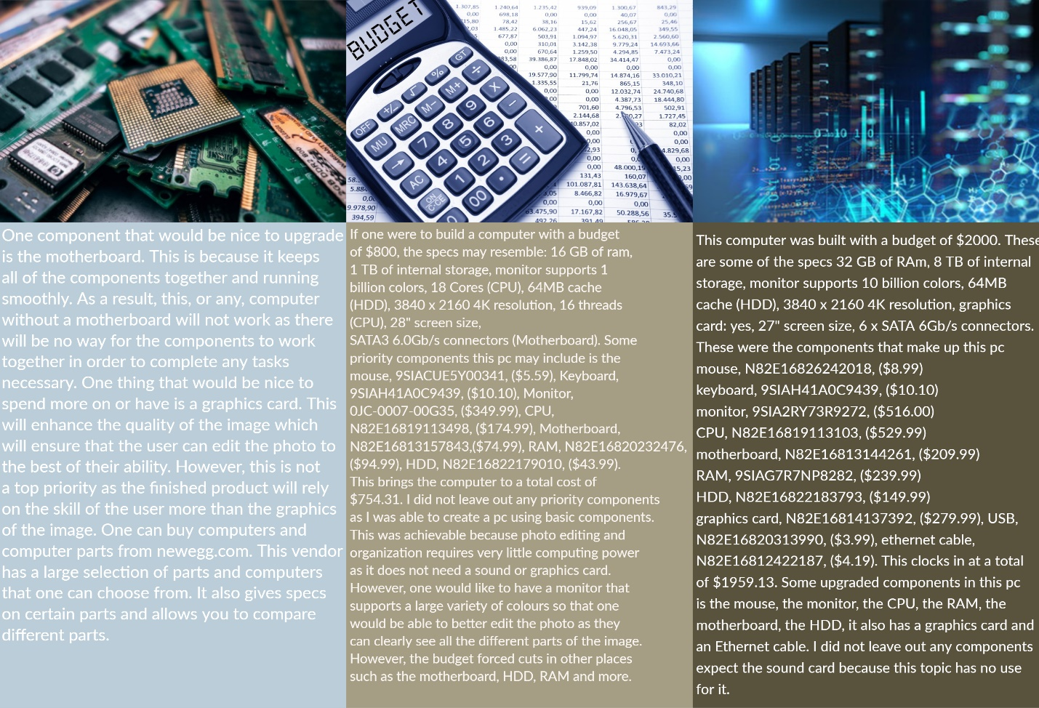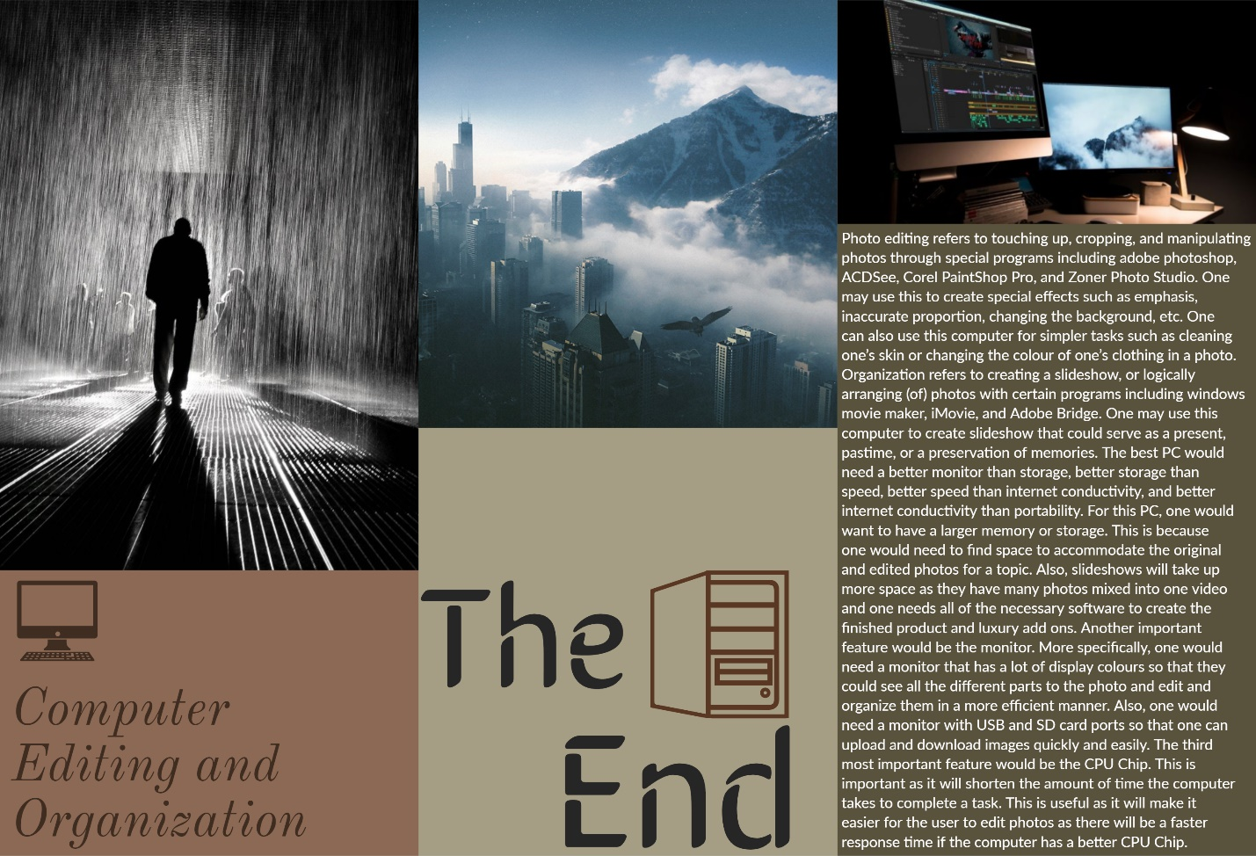

**Appendix A: PC Vendors, Parts, & Customization**

Suggested on-line computer sources:

* [www.newegg.ca](http://www.newegg.ca)
* [www.dell.com/en-ca](http://www.dell.com/en-ca)
* [www.tigerdirect.ca/](http://www.tigerdirect.ca/)
* [www.canadacomputers.com](http://www.canadacomputers.com)

**Appendix B: Application Topics**

|  |  |
| --- | --- |
| **Task** | **Student Name** |
| ***Game Computer*** |  |
| **Photo Editing & Organization** |  |
| ***Business Office Computer*** |  |
| ***Student Home Computer*** |  |
| ***Factory Floor Computer*** |  |
| ***Media Production and Streaming Computer*** |  |
| ***Web Surfing Computer*** |  |
| ***Game Computer*** |  |
| **Photo Editing & Organization** |  |
| ***Business Office Computer*** |  |
| ***Student Home Computer*** |  |
| ***Factory Floor Computer*** |  |
| ***Media Production and Streaming Computer*** |  |
| ***Web Surfing Computer*** |  |
| ***Game Computer*** |  |
| **Photo Editing & Organization** |  |
| ***Business Office Computer*** |  |
| ***Student Home Computer*** |  |
| ***Factory Floor Computer*** |  |
| ***Media Production and Streaming Computer*** |  |
| ***Web Surfing Computer*** |  |